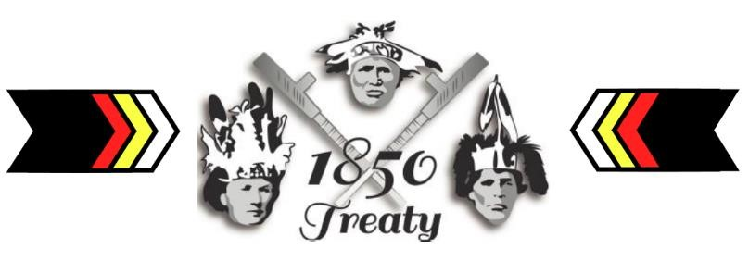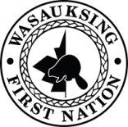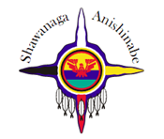

Robinson Huron Treaty Gathering
“Renewing our Relations” - September 21 – 23, 2018
Hosted at: Shawanaga First Nation Pow-Wow Grounds, Ball Diamond

Wasauksing First Nation Community Shuttle Hours
To and From the Gathering

Friday Sept. 21 and Saturday Sept 22, 2018

*Friday Transportation Leaves Wasauksing Complex at 7:30am
(Van- 7 person capacity) Arrives in Shawanaga at 8:30am

*Saturday Transportation Leaves Shawanaga at 11:30 am
(Community Transit Bus Arrives at Wasauksing Complex at 12:15pm
14 person capacity)
Leaves Wasauksing Complex at 12:15pm
Arrives in Shawanaga at 1:00pm

Leaves Shawanaga at 6:00pm
Arrives at Wasauksing Complex at 7:00pm

Sunday Sept. 23, 2018 (Half day session only)
Community Transit Bus- Leaves Wasauksing Complex at 7:30am
14 person capacity Arrives in Shawanaga at 8:30am

Leaves Shawanaga at 2:00pm
Each day the van or bus will leave the complex drive up old track road, around the loop to the main road and out to the bridge. Call- 705-746-2531 to be added to the pick up schedule/route.

